ERASMUS+ PROGRAMME
Project Number: 585980-EPP-1-2017-1-DE-CBHE-JP

MediTec:
Training for Medical Education via Innovative e-Technology

WP1: Preperation and State of Art
WP1 Leader: Lalit Garg

ERASMUS+ PROGRAMME
Project Number: 585980-EPP-1-2017-1-DE-CBHE-JP

MediTec:
Training for Medical Education via Innovative e-Technology

Title: *******
Venue: *******
Date: *******

Table of Contents:

- Introduction: Review, State of the art and Network between partner universities 3
- Prepare operation plans for the training on innovative medical technology: 4
  - Proposed training courses for Academics 4
  - Proposed training courses for Students 11
- Training interest survey 15
  - The training courses at the University of Malta 16
  - The training courses at the Univerzita Pavla Jozefa Safarika v Kosiciach [UPJS], Slovakia 18
  - The training courses at the Masarykova Univerzita [MU], Czech Republic 20
- Feedback on the courses 22

Introduction

As a part of the project there will be several training courses to be organized by the EU-partner institutions:
- University of Malta [UM], Malta;
- Univerzita Pavla Jozefa Safarika v Kosiciach [UPJS], Slovakia; and
- Masarykova Univerzita [MU], Czech Republic.

The audience of these training courses will be from the non-EU partner institutions:
- Jordan University of Science and Technology [JUST], Jordan
- The University of Jordan [UJ], Jordan
- Hashemite University [HU], Jordan
- Princess Sumaya University for Technology [PSUT], Jordan
- University of Duhok [UoD], Iraq
- University of Baghdad [UoB], Iraq
- University of Basra [UOB], Iraq
- Tehran University of Medical Sciences [TUMS], Iran
- Iran University of Medical Sciences [IUMS], Iran
- Yarmouk University [YU], Jordan

This report is summarizing the outcome of a survey carried out to understand the resources available at the EU-partner Institutions and feedback (needs and interests) of the non-EU partner institutions.

Proposed training courses
There are three training courses are proposed by UM, eleven training courses are proposed by UPJS and two training courses are proposed by MU. The proposed dates are during November, January and February. (UPJS initially proposed dates in August, and yet considering the new dates in November). These trainings need to be completed before April 15th, 2019. These can take place independently, preferably first at UPJS, then at UM and then at MU.

Topics for Academics
Malta | Learning Outcomes |  |  | Proposed Date
Advances in Medical Education | Design and deliver effective teaching sessions | Reflect on own teaching performance and provide feedback to others | Recognise when their students are/are not learning | Jan 30th to Feb 02nd, 2019 inclusive
Dental curriculum Review and Update | Observe the implementation of the UOM Faculty of Dentistry curriculum | Obtain feedback on specific aspects of the dental curriculum | Incorporate novel elements to update the dental curriculum | Jan 30th to Feb 02nd, 2019 inclusive
Health Systems Management, Leadership and Informatics | Explain the basic tools, methods of health systems management, leadership and informatics for optimal performance and quality of healthcare delivery | Design training on the basic tools, methods of health systems management, leadership and informatics for optimal performance and quality of healthcare delivery | Update curriculum for medical students by including health systems management, leadership and informatics for optimal performance and quality of healthcare delivery topics | Jan 30th to Feb 02nd, 2019 inclusive
Slovakia
Nursing Care | Observe main tools and simulations used in education of nursing care at UPJS. | Design trainings of practical skills in applying bandages, administration of parenteral medication etc. | Utilise communication skills.  Identify, recognize and discern selected legal and ethical issues in nursing. | November 21st to 24th, 2019 inclusive.
Medical Physiology | Understand Human physiology and background of Sleep medicine, Sleep apnoea and Sleep laboratory. | Observe research in the field of ongoing research in sleep medicine, manage Sleep laboratory and prepare a patient for sleep study. |  | November 21st to 24th, 2019 inclusive.
Medical Informatics | Explain basic concepts of Evidence-Based Medicine. | Understand background of online tools and platforms used in medical education at UPJS. |  | November 21st to 24th, 2019 inclusive.
Forensic Medicine | Methods in forensic medicine, medico-legal expertise, examination and autopsy, laboratory investigation and cooperation with external institutions. | Death certification. Autopsy protocol. Medico-legal statistics and individual cases. |  | November 21st to 24th, 2019 inclusive.
Experimental Medicine | Understand gut microbiota and gut barrier in health and disease.  New findings on the effects of lactobacilli in experimentally induced colorectal carcinoma in rats. | Realize in vitro study of the human gut microbiota using SHIME® model. | Observe application of omega-3 PUFAs in prevention of chronic diseases. | November 21st to 24th, 2019 inclusive.
Human Anatomy | Cadavers and education movies based on real dissections. | Real dissections in dissecting rooms. | Our way of teaching human anatomy (lectures and practical lessons). | November 21st to 24th, 2019 inclusive.
First Aid in Health Care Disciplines | Simulations in anaesthesia and intensive care, first aid, critical decisions. Critical decisions and important steps in patients with loss of consciousness and circulatory arrest. | Airway management and ventilatory support during failure of respiration. | Defibrillation and cardioversion. | November 21st to 24th, 2019 inclusive.
Neonatology | New technologies in prenatal and neonatal care. Patient’s repositories. | Serving all necessary interventions, noninvasive ventilation, conventional ventilation, HFO and iNO. |  | November 21st to 24th, 2019 inclusive.
Dental Medicine | Practical training of preclinical subject of Dental medicine - Propaedeutic of Dental Medicine. | Practical training of various clinical subject of Dental medicine. |  | November 21st to 24th, 2019 inclusive.
Cardiovascular Diseases | Advances in heart diseases management. Interventions and diagnostics in 21st century.
Biomedical engineering | Advances in custom implants, materials and technologies. | Observe additive manufacturing procedures. | Discuss imaging systems including x-ray, CT, MRI, Ultrasound, gamma camera | November 21st to 24th, 2019 inclusive.
Czech Republic
HC quality management concepts | defining quality, measuring quality, understanding existing quality approaches, implementing HC quality, understanding needs of HC stakeholders | ability to use simple tools and processes for evaluation and implementation of quality improvement, understading and practical use of teams and teamworking |  | January 7th. through February 7th. 2019
HC digital environment - Information society transformation of HC services | understanding the logics of societal change, get insight into oportunities, limitations and risks at the turnover of a society from one to another (industrial society into information society), reflect on the right habbits, instincts and reflexes (behavior) in th framework of a given society | ability to make decisions on when and how to use digital support in HC rather than just re-using what others have already done, ability to identify and propose "inventive digital solutions" for issues of everyday HC services |  | January 7th. through February 7th. 2019
Imaging methods in medicine, Electronic library university resources, EBM | Exploring possibilities of imaging methods in medicine as support in medical decision making, understanding the principles of existing imaging methods in order to minimize risks and maximize benefits from digital imaging, exploring existing online resources with respect to medical decision-making in the contextual shift from "eminence-based medicine/authorities based medicine" to evidence based medicine | Better understanding of medialized (transformed - "secondhand") information |  | January 7th. through February 7th. 2019

Topics for Students
Malta | Learning Outcomes |  |  | Proposed Date
Students as Teachers (Peer Assisted Learning) | Design and deliver effective teaching sessions | Reflect on own teaching performance and provide feedback to others | Recognise when their students are/are not learning | Jan 30th to Feb 02nd, 2019 inclusive
Case Based Clinical Anatomy Revision Course | Apply regional anatomical knowledge to case-based clinical situations |  |  | Jan 30th to Feb 02nd, 2019 inclusive
Health care informatics | Explain the basic tools and methods of health care informatics and their applications |  |  | Jan 30th to Feb 02nd, 2019 inclusive
Slovakia
Nursing Care | Use tools and simulation equipment in nursing care. | Gain practical skills in applying bandages, administration of parenteral medication etc. through trainings running in the simulation laboratories. | Utilize learned skills to communicate effectively with patient and team members. | November 21st to 24th, 2019 inclusive.
Medical Informatics | Understand principles of Evidence-Based Medicine. | Describe medical data and perform their statistical analysis. | Use software tools and simulations integrated in education of medical students at UPJS. | November 21st to 24th, 2019 inclusive.
Human Anatomy | Cadavers and education movies based on real dissections. | Real dissections in dissecting rooms. | Our way of teaching human anatomy (lectures and practical lessons). | November 21st to 24th, 2019 inclusive.
First Aid in Health Care Disciplines | Simulations in anaesthesia and intensive care, first aid, critical decisions. Critical decisions and important steps in patients with loss of consciousness and circulatory arrest. | Airway management and ventilatory support during failure of respiration. | Defibrillation and cardioversion. | November 21st to 24th, 2019 inclusive.
Medical Physiology | Will learn about sleep medicine, difference between types of respiratory disorders during sleep. Polysomnography as diagnostic method in sleep medicine, how to diagnose obstructive sleep apnoea and how to treat it. | Interpretation of polysomnographic recordings and results of overnight polysomnography. How to prevent obstructive sleep apnoea. What to do recommendation for the patients. |  | November 21st to 24th, 2019 inclusive.
Dental Medicine | Practical skills of conservative medicine, prosthetics, dentoalveolar surgery on models, on trainers. | Practical skills of various department of Dentistry. |  | November 21st to 24th, 2019 inclusive.
Czech Republic
Biophysics and instrumental techniques |  |  |  | January 7th. through February 7th. 2019
Practicals in biophysics |  |  |  | January 7th. through February 7th. 2019
Collaboration and teamworking in HC |  |  |  | January 7th. through February 7th. 2019

Training interest survey
As a part of the project there will be several training courses to be organised by the EU-partner institutions (UM, UPJS, and MU). The audience of these training courses will be from the non-EU partner institutions (JUST, UJ, HU, PSUT, UoD, UoB, UOB, TUMS, IUMS and YU). Another survey is carried out to gather feedback and information about the potential attendees of these courses. The responses were provided by only 5 institutions:
- Princess Sumaya University for Technology [PSUT], Jordan
- University of Duhok [UoD], Iraq
- Jordan University of Science and Technology [JUST], Jordan
- The University of Jordan [UJ], Jordan
- Hashemite University [HU], Jordan

The interest in the training courses at the University of Malta:
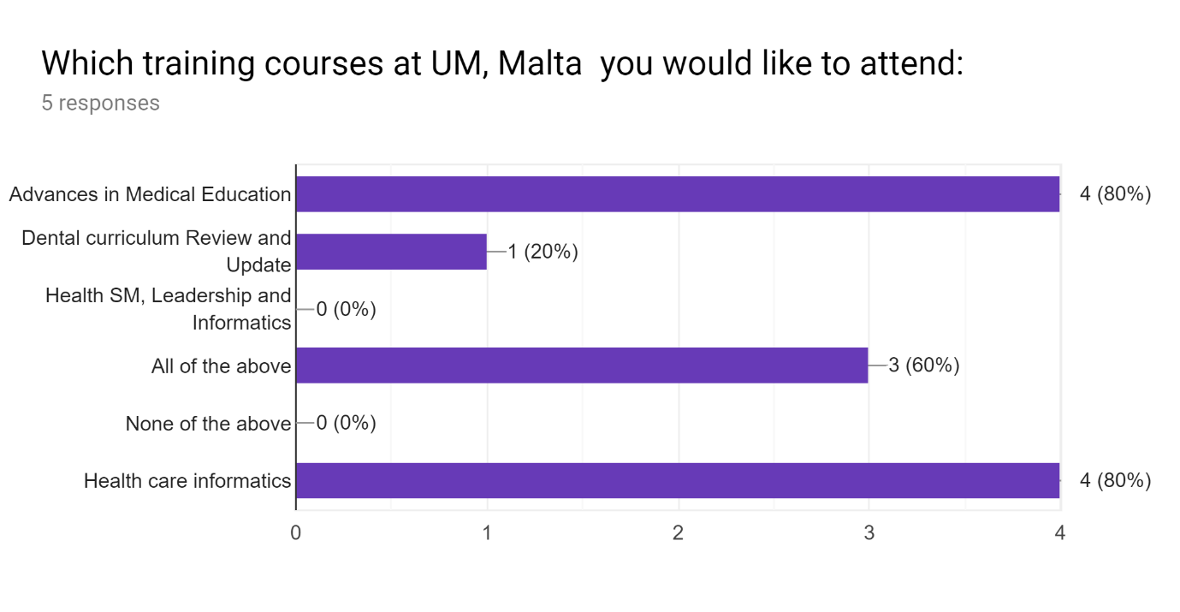

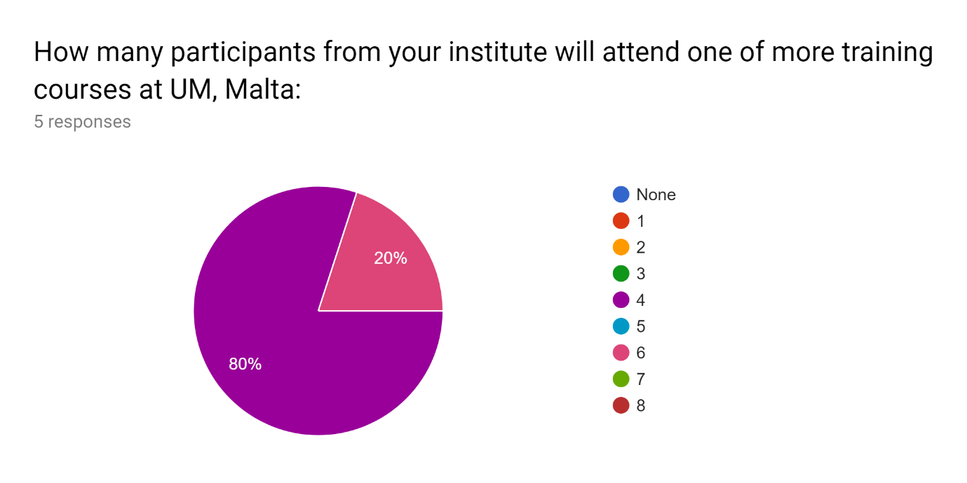
Here the Princess Sumaya University for Technology [PSUT], Jordan proposed 6 participants and all other would like to send only 4 participants.

Name of the participants from your institute will attend one of more training courses at UM, Malta:3 responses
The University of Jordan [UJ], Jordan
- Prof. Ahmed Al- Salaymeh
- Prof. Nathir obiedat
- Prof. Dia Abu alnadi
- Dr. Yazan Hassouneh
Princess Sumaya University for Technology [PSUT], Jordan
- Prof. Walid A. Salameh
- Dr. Murad Ahmad Jallad
- Dr. Fadi R. Shahroury
- Eng. Omar Hisham Alasali
- Mr. Yazan Abdallah AbuYaghi
- Miss. Rosana Marar
Hashemite University [HU], Jordan
- Prof. Ahmad Al-Khasawneh
- Dr. Aiman Al Sharei
- Dr. Mohammad Al-Tamimi
- Dr. Bashar Hammad

The interest in the training courses at the Univerzita Pavla Jozefa Safarika v Kosiciach [UPJS], Slovakia:

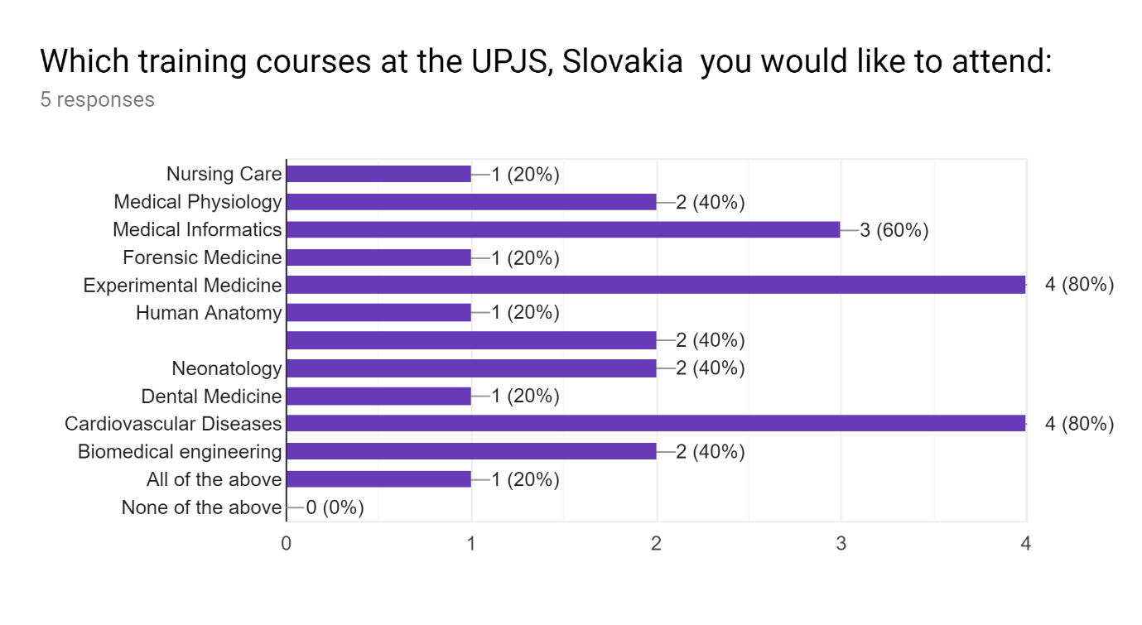
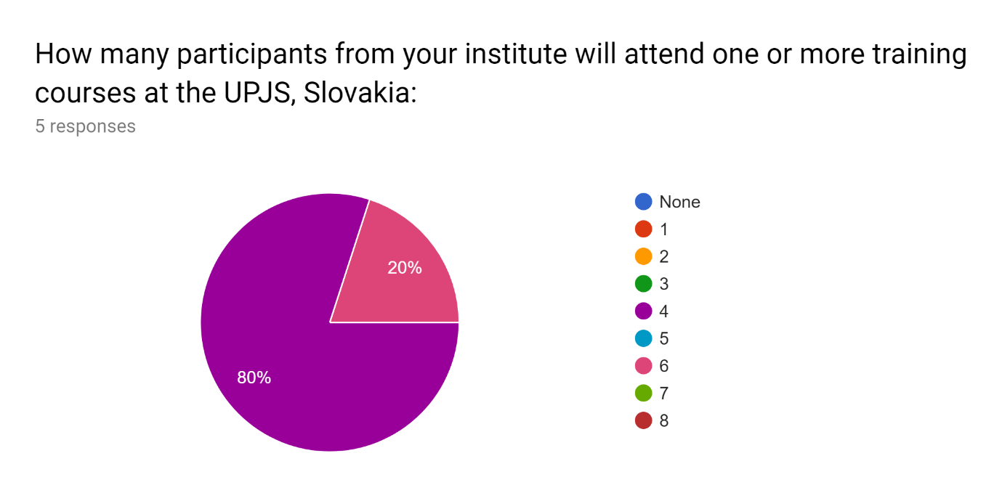
Here the Princess Sumaya University for Technology [PSUT], Jordan proposed 6 participants and all other would like to send only 4 participants.

Name of the participants from your institute will attend one or more training courses at the UPJS, Slovakia:3 responses
The University of Jordan [UJ], Jordan
- Prof. Ahmed Al- Salaymeh
- Prof. Nathir obiedat
- Prof. Dia Abu alnadi
- Dr. Yazan Hassouneh
Princess Sumaya University for Technology [PSUT], Jordan
- Prof. Walid A. Salameh
- Dr. Murad Ahmad Jallad
- Dr. Fadi R. Shahroury
- Eng. Omar Hisham Alasali
- Mr. Yazan Abdallah AbuYaghi
- Miss. Rosana Marar
Hashemite University [HU], Jordan
- Prof. Ahmad Al-Khasawneh
- Dr. Aiman Al Sharei
- Dr. Mohammad Al-Tamimi
- Dr. Bashar Hammad

The interest in the training courses at the Masarykova Univerzita [MU], Czech Republic):

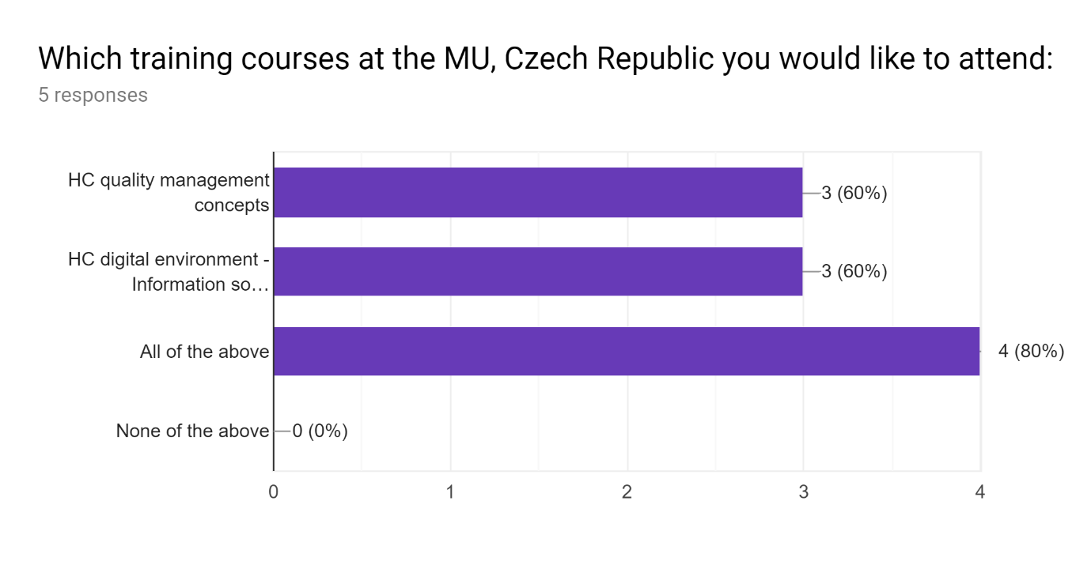

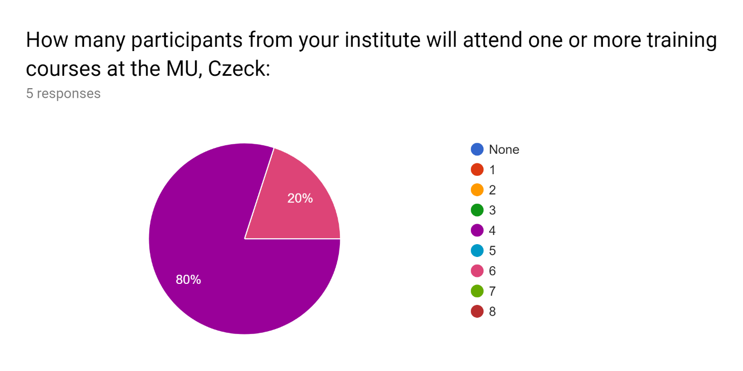
Here the Princess Sumaya University for Technology [PSUT], Jordan proposed 6 participants and all other would like to send only 4 participants.

Name of the participants from your institute will attend one or more training courses at the MU, Czeck:3 responses
The University of Jordan [UJ], Jordan
- Prof. Ahmed Al- Salaymeh
- Prof. Nathir obiedat
- Prof. Dia Abu alnadi
- Dr. Yazan Hassouneh
Princess Sumaya University for Technology [PSUT], Jordan
- Prof. Walid A. Salameh
- Dr. Murad Ahmad Jallad
- Dr. Fadi R. Shahroury
- Eng. Omar Hisham Alasali
- Mr. Yazan Abdallah AbuYaghi
- Miss. Rosana Marar
Hashemite University [HU], Jordan
- Prof. Ahmad Al-Khasawneh
- Dr. Aiman Al Sharei
- Dr. Mohammad Al-Tamimi
- Dr. Bashar Hammad

Feedback on the courses
The feedback we received from the non-EU partner institutions is as follows:
- Wisam A. Shihadeh found that the Health informatics training course proposed by UM is quite similar to the Medical Informatics training course proposed by UPJS.
Response: Both courses are quite different and there is no or minimal overlap between them. Also, now the course has been changed to “Health Systems Management, Leadership and Informatics”
- Wisam A. Shihadeh wondered if the Dental curriculum Review and Update training course proposed by UM is within the scope of MediTec.
Response: Yes the dental curriculum is a part of medicine education at UM and it is within the scope of MediTec.
- Wisam A. Shihadeh also like to have real dissection of cadavers in legal cases included in the Experimental Medicine training course proposed by UPJS.
Response: A brilliant suggestion and will surely be considered.
- Fahmi Rub asked if the Biophysics and instrumental techniques training course proposed by MU is related to medical education and if yes, at what level of the study.
- kusai al-muqbel suggested to add sectional imaging (radiological anatomy) in the Human Anatomy training course proposed by UPJS.
- kusai al-muqbel suggested to discuss imaging systems including x-ray, CT, MRI, Ultrasound, gamma camera as a part of the Biomedical engineering training course proposed by UPJS.
- kusai al-muqbel expressed his interest toward the Practicals in biophysics training course proposed by MU, particularly for understanding physical background of radiology.
- Mohamad Sadegh Ghasemi proposed to have all training courses together to help with the visa. He commented: “Please Note: Should not all training be at the same time for other institution. Here in Iran we have to get entry visa for those counties, which are running the programs. At least we need 8 weeks for applying for entry visa. Therefor you need to reconsider the training time and invitation letters for participation.”
- Initially UM also prosed the training course on “An introduction to Traditional Chinese Medicine“. However, as commented by Mandana Shirazi, this topic is very specific and it is not the same in all medical curriculum in those countries which is available in those counties which are involved in Medical Technology Project.
Response: After considering the comments, the proposed training course is withdrawn.
- Mandana Shirazi liked the idea of including team work in the training course proposed by UPJS “HC quality management concepts”. He commented: “Team work is mostly soft skill and communication skill is the most important domain of it. Which effects on inter personal communication.”
In general, there are positive responses and interest among the potential attendees of these training courses.

