“Training for Medical education via innovative eTechnology (MediTec) an Erasmus+ Programme
(Grant Number: 585980-EPP-1-2017-1-DE-EPPKA2-CBHE-JP)
Capacity-Building projects in the field of Higher Education
(CBHE)
The training needs survey report

Introduction: As a part of the project there will be several training courses to be organized by the EU-partner institutions:
University of Malta [UM], Malta;
Univerzita Pavla Jozefa Safarika v Kosiciach [UPJS], Slovakia; and
Masarykova Univerzita [MU], Czech Republic).

The audience of these training courses will be from the non-EU partner institutions:
Jordan University of Science and Technology [JUST], Jordan
The University of Jordan [UJ], Jordan
Hashemite University [HU], Jordan
Princess Sumaya University for Technology [PSUT], Jordan
University of Duhok [UoD], Iraq
University of Baghdad [UoB], Iraq
University of Basra [UOB], Iraq
Tehran University of Medical Sciences [TUMS], Iran
Iran University of Medical Sciences [IUMS], Iran
Yarmouk University [YU], Jordan

This report is summarizing the outcome of a survey carried out to understand the resources available at the EU-partner Institutions and feedback (needs and interests) of the non-EU partner institutions.
Proposed training courses: There are three training courses are proposed by UM, eleven training courses are proposed by UPJS and two training courses are proposed by MU. The proposed dates are during January and February. (UPJS initially proposed dates in August and November, and yet considering the new dates in January and February). These trainings need to be completed before April 15th, 2019. These can take place independently, preferably first at UM and then at UPJS and then at MU.
Malta | Learning Outcomes |  |  | Proposed Date
Advances in Medical Education | Design and deliver effective teaching sessions | Reflect on own teaching performance and provide feedback to others | Recognise when their students are/are not learning | Jan 21 to Feb 8, 2019 inclusive
Dental curriculum Review and Update | Observe the implementation of the UOM Faculty of Dentistry curriculum | Obtain feedback on specific aspects of the dental curriculum | Incorporate novel elements to update the dental curriculum | Jan 21 to Feb 8, 2019 inclusive
Health care informatics | Explain the basic tools and methods of health care informatics and their applications | Design training on the basic health care informatics tools and methods | Update curriculum for medical students by including some of the health informatics topics | Jan 21 to Feb 8, 2019 inclusive
Slovakia
Nursing Care | Observe main tools and simulations used in education of nursing care at UPJS. | Design trainings of practical skills in applying bandages, administration of parenteral medication etc. | Utilise communication skills.  Identify, recognize and discern selected legal and ethical issues in nursing.
Medical Physiology | Understand Human physiology and background of Sleep medicine, Sleep apnoea and Sleep laboratory. | Observe research in the field of ongoing research in sleep medicine, manage Sleep laboratory and prepare a patient for sleep study. |  | August 12, 2018
Medical Informatics | Explain basic concepts of Evidence-Based Medicine. | Understand background of online tools and platforms used in medical education at UPJS.
Forensic Medicine | Methods in forensic medicine, medico-legal expertise, examination and autopsy, laboratory investigation and cooperation with external institutions. | Death certification. Autopsy protocol. Medico-legal statistics and individual cases.
Experimental Medicine | Understand gut microbiota and gut barrier in health and disease.  New findings on the effects of lactobacilli in experimentally induced colorectal carcinoma in rats. | Realize in vitro study of the human gut microbiota using SHIME® model. | Observe application of omega-3 PUFAs in prevention of chronic diseases.
Human Anatomy | Cadavers and education movies based on real dissections. | Real dissections in dissecting rooms. | Our way of teaching human anatomy (lectures and practical lessons).
First Aid in Health Care Disciplines | Simulations in anaesthesia and intensive care, first aid, critical decisions. Critical decisions and important steps in patients with loss of consciousness and circulatory arrest. | Airway management and ventilatory support during failure of respiration. | Defibrillation and cardioversion.
Neonatology | New technologies in prenatal and neonatal care. Patient’s repositories. | Serving all necessary interventions, noninvasive ventilation, conventional ventilation, HFO and iNO.
Dental Medicine | Practical training of preclinical subject of Dental medicine - Propaedeutic of Dental Medicine. | Practical training of various clinical subject of Dental medicine.
Cardiovascular Diseases | Advances in heart diseases management. Interventions and diagnostics in 21st century.
Biomedical engineering | Advances in custom implants, materials and technologies. | Observe additive manufacturing procedures. |  | discuss imaging systems including x-ray, CT, MRI, Ultrasound, gamma camera
Czech Republic
HC quality management concepts | defining quality, measuring quality, understanding existing quality approaches, implementing HC quality, understanding needs of HC stakeholders | ability to use simple tools and processes for evaluation and implementation of quality improvement, understading and practical use of teams and teamworking |  | January 7th. through February 7th. 2019
HC digital environment - Information society transformation of HC services | understanding the logics of societal change, get insight into oportunities, limitations and risks at the turnover of a society from one to another (industrial society into information society), reflect on the right habbits, instincts and reflexes (behavior) in th framework of a given society | ability to make decisions on when and how to use digital support in HC rather than just re-using what others have already done, ability to identify and propose "inventive digital solutions" for issues of everyday HC services |  | January 7th. through February 7th. 2019

Feedback on these course: The feedback we received from the non-EU partner institutions is as follows:
- Wisam A. Shihadeh found that the Health informatics training course proposed by UM is quite similar to the Medical Informatics training course proposed by UPJS. However, both courses are quite different and there is no or minimal overlap between them.
- Wisam A. Shihadeh wondered if the Dental curriculum Review and Update training course proposed by UM is within the scope of MediTec.
- Wisam A. Shihadeh also like to have real dissection of cadavers in legal cases included in the Experimental Medicine training course proposed by UPJS.
- Fahmi Rub asked if the Biophysics and instrumental techniques training course proposed by MU is related to medical education and if yes, at what level of the study.
- kusai al-muqbel suggested to add sectional imaging (radiological anatomy) in the Human Anatomy training course proposed by UPJS.
- kusai al-muqbel suggested to discuss imaging systems including x-ray, CT, MRI, Ultrasound, gamma camera as a part of the Biomedical engineering training course proposed by UPJS.
- kusai al-muqbel expressed his interest toward the Practicals in biophysics training course proposed by MU, particularly for understanding physical background of radiology.
- Mohamad Sadegh Ghasemi proposed to have all training courses together to help with the visa. He commented: “Please Note: Should not all training be at the same time for other institution. Here in Iran we have to get entry visa for those counties, which are running the programs. At least we need 8 weeks for applying for entry visa. Therefor you need to reconsider the training time and invitation letters for participation.”
- Initially UM also prosed the training course on “An introduction to Traditional Chinese Medicine“. However, as commented by Mandana Shirazi, this topic is very specific and it is not the same in all medical curriculum in those countries which is available in those counties which are involved in Medical Technology Project. After considering the comments, the proposed training course is withdrawn.
- Mandana Shirazi liked the idea of including team work in the training course proposed by UPJS “HC quality management concepts”. He commented: “Team work is mostly soft skill and communication skill is the most important domain of it. Which effects on inter personal communication.”
In general there are positive responses and interest among the potential attendees of these training courses.
Training needs Survey
As a part of the project there will be several training courses to be organised by the EU-partner institutions (UM, UPJS, and MU). The audience of these training courses will be from the non-EU partner institutions (JUST, UJ, HU, PSUT, UoD, UoB, UOB, TUMS, IUMS and YU). Another survey is carried out to gather feedback and information about the potential attendees of these courses. The responses were provided by only 5 institutions:
- Princess Sumaya University for Technology [PSUT], Jordan
- University of Duhok [UoD], Iraq
- Jordan University of Science and Technology [JUST], Jordan
- The University of Jordan [UJ], Jordan
- Hashemite University [HU], Jordan

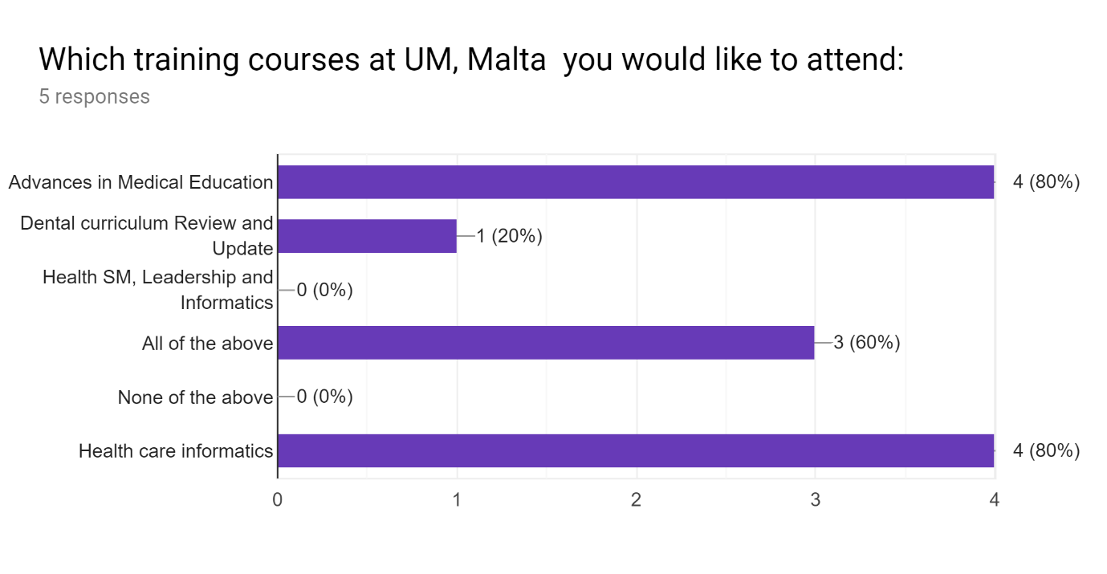

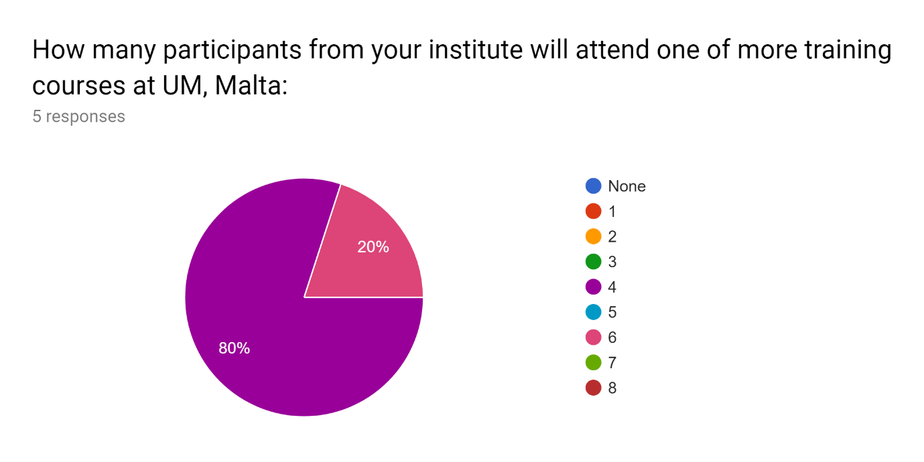

Name of the participants from your institute will attend one of more training courses at UM, Malta:3 responses
1-Prof. Ahmed Al- Salaymeh 2-Prof. Nathir obiedat 3- Prof. Dia Abu alnadi 4-Dr. Yazan Hassouneh
Prof. Walid A. Salameh Dr. Murad Ahmad Jallad Dr. Fadi R. Shahroury Eng. Omar Hisham Alasali Mr. Yazan Abdallah AbuYaghi Miss. Rosana Marar
Prof. Ahmad Al-Khasawneh Dr. Aiman Al Sharei Dr. Mohammad Al-Tamimi Dr. Bashar Hammad

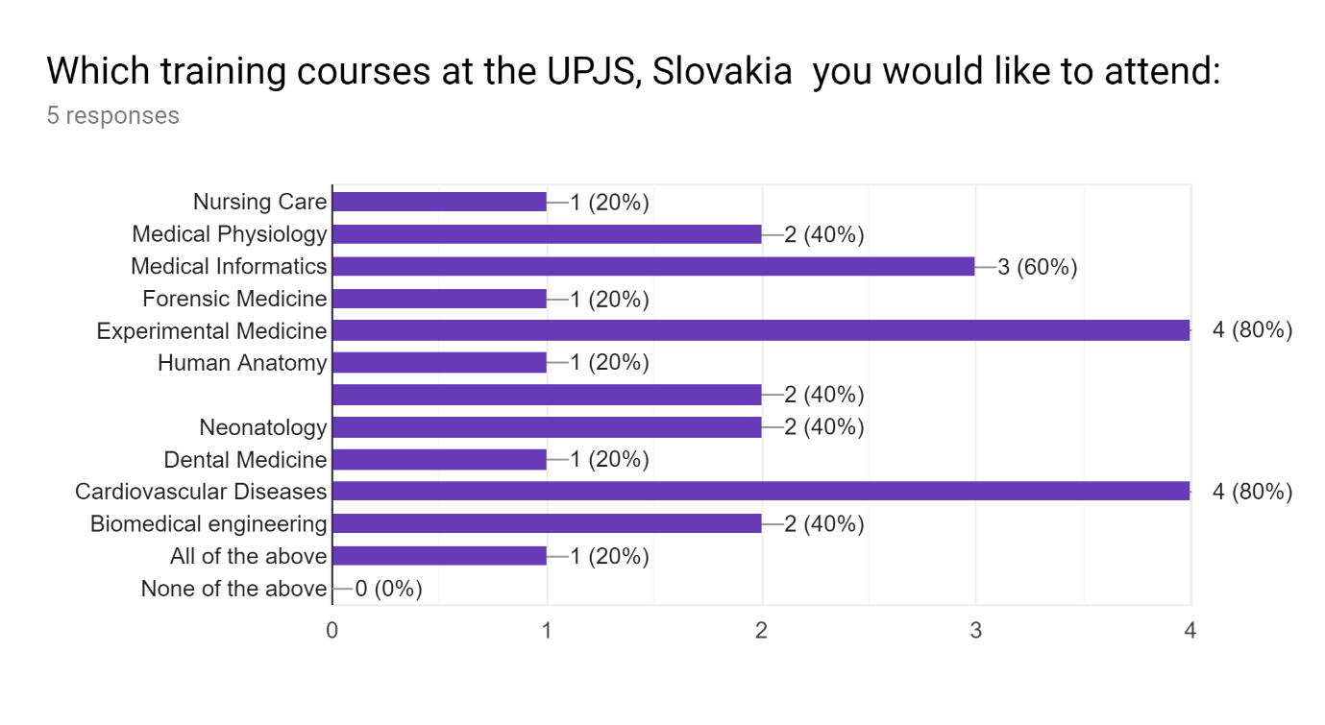
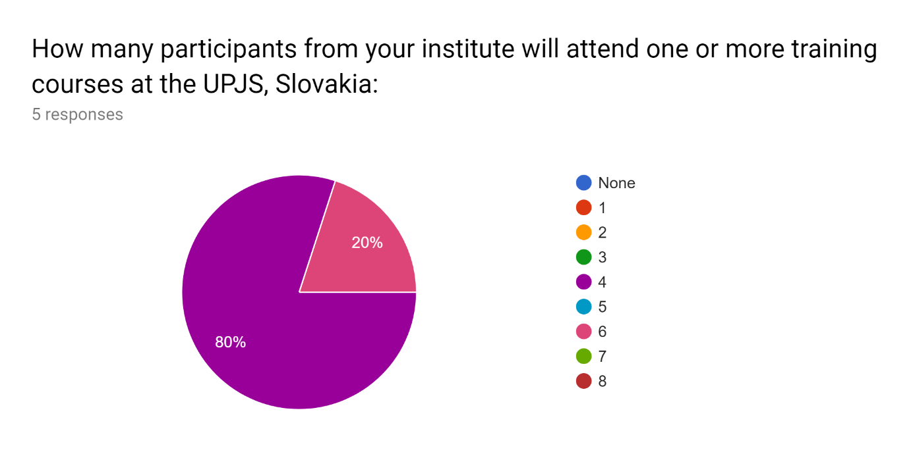
Name of the participants from your institute will attend one or more training courses at the UPJS, Slovakia:3 responses
1-Prof. Ahmed Al- Salaymeh 2-Prof. Nathir obiedat 3- Prof. Dia Abu alnadi 4-Dr. Yazan Hassouneh
Prof. Walid A. Salameh Dr. Murad Ahmad Jallad Dr. Fadi R. Shahroury Eng. Omar Hisham Alasali Mr. Yazan Abdallah AbuYaghi Miss. Rosana Marar
Prof. Ahmad Al-Khasawneh Dr. Aiman Al Sharei Dr. Hanan Al-Modallal Dr. NAWAL HIJJAWI

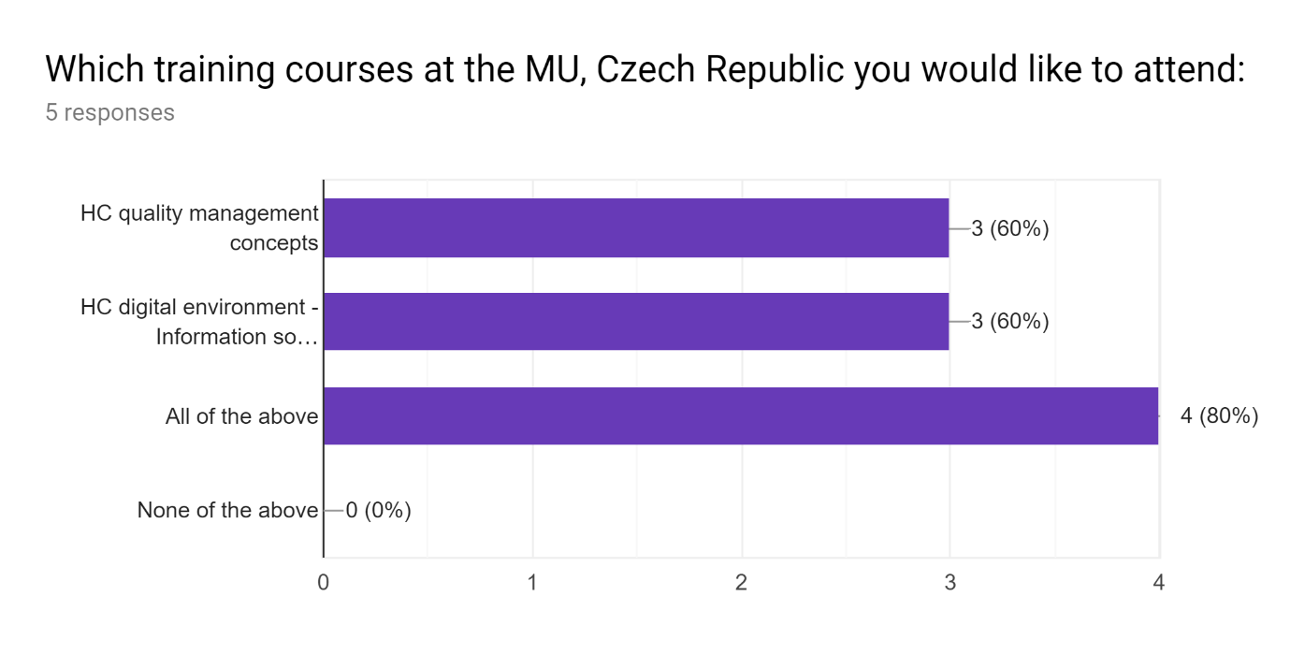

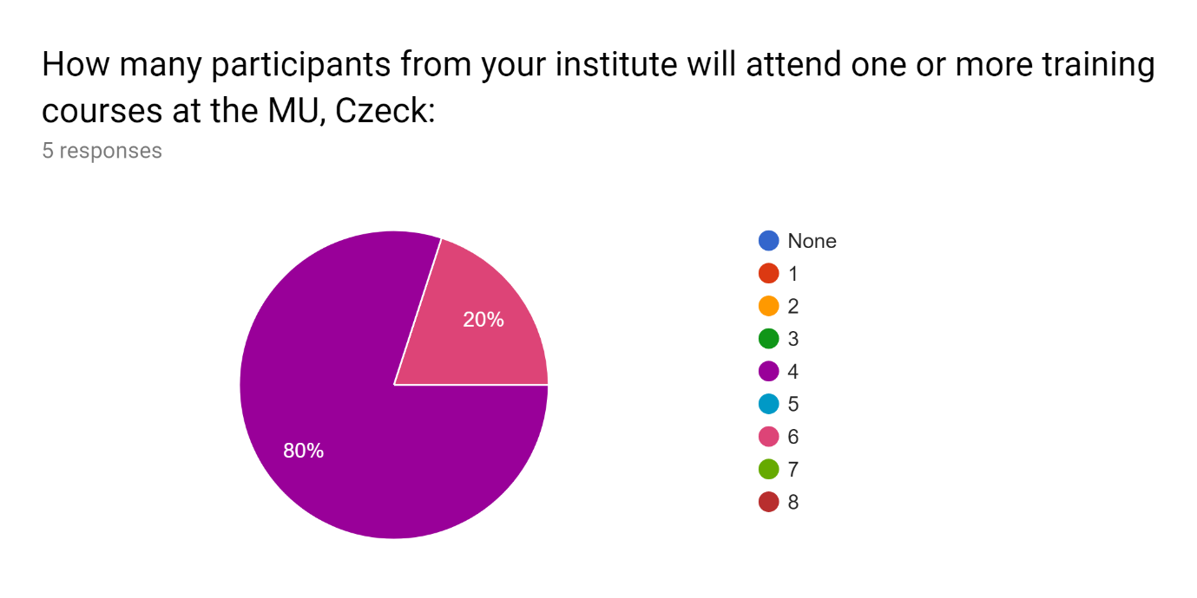
Name of the participants from your institute will attend one or more training courses at the MU, Czeck:3 responses
1-Prof. Ahmed Al- Salaymeh 2-Prof. Nathir obiedat 3- Prof. Dia Abu alnadi 4-Dr. Yazan Hassouneh
Prof. Walid A. Salameh Dr. Murad Ahmad Jallad Dr. Fadi R. Shahroury Eng. Omar Hisham Alasali Mr. Yazan Abdallah AbuYaghi Miss. Rosana Marar
Prof. Ahmad Al-Khasawneh Prof. Darwish Badran Dr. Bashar Hammad Dr. Aiman Al Sharei

